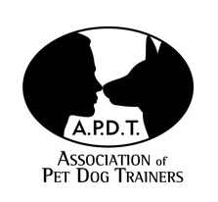
Freston Pet Dog Training

C/O Keyna Mullany, 13 Palfrey Heights, Brantham, Manningtree, Essex, CO11 1SE
Tel: 01206 391113 /07599 794734
Email: kmmdogtrainer@gmail.com

Thank you for your enquiry about our "Early Days" Puppy Foundation classes. The next available course starts on Monday 12th March 2018 from 6.30 -7.30 p.m at Freston Village Hall. Freston St, Freston. IP9 1AH. This is an eight session course aimed at providing an opportunity for younger puppies (between 12-20 weeks when they start) to socialise with others in a safe environment, as well as meeting new people and starting some gentle training such as walking on the lead, recall, being handled etc. We include the Kennel Club Good Citizen Dog Scheme so your puppy can get the “Puppy Foundation” award during his training.

Numbers are limited so it is necessary to book your place early. Please print and fill in the form and send it with to me with the course fee of £70.00 as soon as possible to secure your place. A second puppy in the same household is £65.00. (Cheques payable to K Mullany for online payment the bank details are below, or you can use the online shop on the website: www.frestonpetdogtraining.co.uk/pets-n-pupstraining-courses.php)
The first lesson is an introductory talk and demonstration so will be without the puppy. This allows us to sort out paperwork (Please bring your Vaccination Certificate) and discuss the early puppy problems which many owners experience.

We look forward to hearing from you soon.
Regards,
Keyna Mullany
APDT Mem No. 00615
To pay online, the bank details are: CoOperative Bank
Account: K M Mullany & Lynn Riddell
Sort code: 08-93-00 Acc No: 07435241

Early Days/Puppy Foundation Puppy Registration Form
Puppy socialization classes for puppies aged 12 -20 weeks.

Owner's Name ____________________ Start Date 8/1/18 at Freston
Address_____________________________________________________________________________________________________________________________________________________Post Code ________________________
Tel No: Home:__________________________ Work:_____________________________
E-mail___________________________________________________________________
To enable us to help you as much as possible, please fill in these details about your Puppy.

Name: __________________ Breed: _________ Colour_______

Age / (DOB if known): ___________

Male/Female* Neutered Yes / No* (* Delete as appropriate)

Age when acquired: ___________________

Where did you get him/her from? _____________________________________________

Other people in the household: Adults,(over 16)____________ Children:______________

Other Pets _______________________________________________________________

Who normally cares for the puppy _____________________________________________

Usual Diet: _______________________________________________________________

Does your puppy have access to a garden? _____________________________________

How often is he/she walked, and for how long? ______________________________________________

Is he/she normally playful?___________________________________________________
Does he/she ever get aggressive during play?____________________________________
Is he/she ever possessive over toys, chews or food? _____________________________
While some problems can be sorted in class others may require individual behaviour consultation or one-to-one training to help you and your dog. (Phone 01206 391113 to discuss this)

Is your puppy (Tick where appropriate)
Nervous of other dogs________ Aggressive to other dogs ______
Aggressive to people________ Overexcitable with visitors ______
Destructive or noisy when left___ Nervous of people or children_____
Unresponsive to your requests___ Ever bitten anyone ______
Difficult to groom and handle___ Having housetraining problems____

Any other problems (however small) _________________________________________________________________________________________________________________________________________________________________________________________________________________________

Health and Medical History :
Name and Address of Veterinary Practice your dog is registered with:

Date of last vaccinations (please bring your Vaccination Certificate when you come ): ___________________________

Injuries or Illnesses: __________________________________________________________________________________________________________________________________________________

Thankyou for filling in all this information about your puppy. It will be very helpful.

Photographs and Video
There may be occasions where we take photographs or video of special events or you and dogs working etc. We may wish to use these to promote the classes or to illustrate handouts or other educational material. Please sign below to give permission for us to do this.

I do / do not give permission for my dog’s image to be used by Keyna Mullany and Freston Pet Dog training in educational and promotional material.

Signature_______________________ Date________________

Data Protection:- Course Register and the Kennel Club
To register your future success on the Puppy Foundation Course, and other Good Citizens Dog Scheme Tests, we are asked to send your name and address up to the Kennel Club on a course register. They may then contact you later with info about doggy things and events.
Please sign to allow us to submit your details.
I do / do not give permission for my details to be registered with the Kennel Club.

Signature_______________________ Date________________

How did you hear about us?

Vet_____ Pet Shop ______ Friends /Family _______ Other ______________________

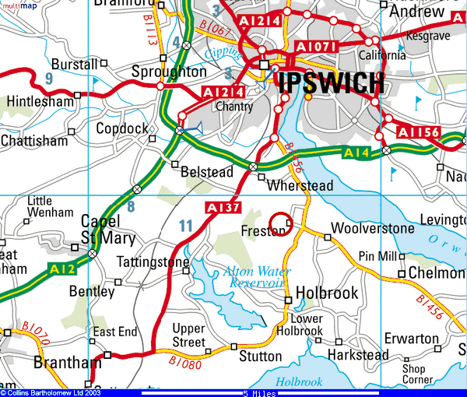

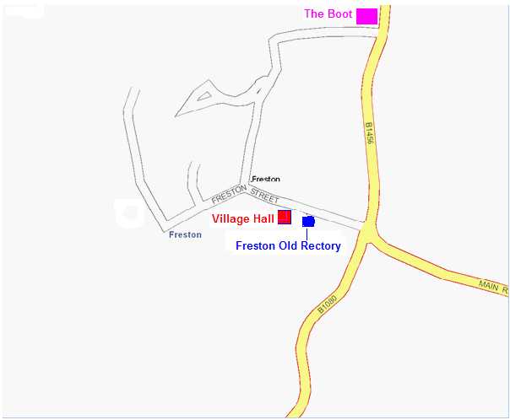

Information for Pet Dog Training Course
& Early Days Puppy Foundation classes

The following guidelines will ensure that you have everything you may need when you come training.
What to wear.
Trousers with pockets for titbits are best as a skirt can flap in the dog's face as you walk and put him off. If you have no pockets a "bum bag" to keep treats in will do.

Soft non-slip shoes or trainers so you can keep a good grip on the floor and should you tread on the dog you will not hurt him. We may take the dogs for a little walk round the field which can be muddy so wellies may be needed if it has been wet.
Puppies can be excitable and grab things so long hair should be tied back so it does not hang over the dog when you bend dow. The same applies to scarves or dangly jewellery.
What your dog should wear.
A flat buckle or clip on collar with an identification tag with your name and address on it (a legal requirement even if your dog is microchipped or tattooed), or a fixed body harness (ie not the “anti pulling” type which tightens under the front legs), webbing, leather or rope lead, not an extending lead. Choke chains or slip ropes are not permitted in any classes.

For dogs which pull a lot a "Gentle leader", “Halti, or ”Dogmatic” headcollar is recommended, as you will have more control and you can then spend time praising the dog for being good, instead of struggling. Different makes suit different dogs and we can advise you on the best option for your individual dog. For dogs who cannot wear a headcollar and short nosed breeds we have found the “Halti Harness” to be very good.

Your dog should bring a mat or piece of bedding to settle on, his favourite toy and plenty of MEATY SMELLY titbits for rewards. Examples are hot dog sausage, cheese, or liver treats. Ther are some ideas below

He should also bring his vaccination certificate as we need to see it. It is recommended to get him vaccinated against "Kennel Cough" which is not just found in kennels, as there is a lot of it about at the moment. If you dog has had to be boarded out, please don't bring him to class that week, in case he has caught it. You are welcome to come yourself and watch though so you do not miss anything.

Please do not feed your dog less than 3 hrs before coming as all the excitement can make them go to the toilet more, and don't forget your "poop scoop" (a plastic bag will do) so we can keep the venue clean.
Do not bring any bitch in season for obvious reasons!

Dog training can be very rewarding and improves the quality of life for both dog and owner as a well-behaved dog is easier to live with and can be taken out and have more fun! There are clubs for various canine activities around the area and if you fancy having a go at any of them after doing this course, we have contact numbers available.

All the best and we look forward to meeting you.

